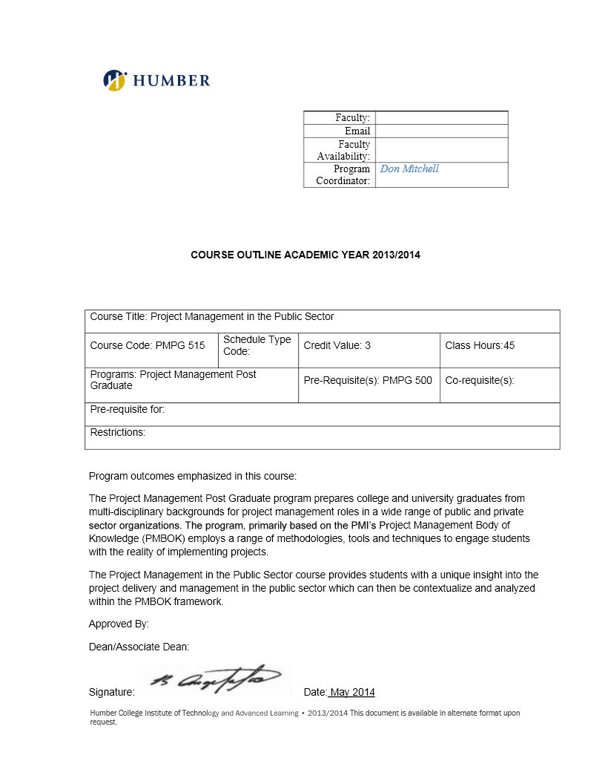

**BUS 5003 - Project Charter**

***Breaking Barriers in Housing***

***Document Version History***

|  |  |  |
| --- | --- | --- |
| Creation / Change Date | Author | Reason for Change |
| 2/12/2025 | Ladan Asempour | Re-writing the project overview as an executive summary |
| 2/26/2025 | Ladan Asempour | Adding go-live dates to the project preliminary schedule |
| 2/28/2025 | Ladan Asempour | Updating sub-objectives on sections 3.0 & 4.0 (to align with the Appendix A requirements for drawing the project network) |
|  |  |  |
|  |  |  |

|  |
| --- |
| Distribution List |
| 1. Ladan Asempour |
| 1. Alexandra Gladkova |
| 1. Kushwanth Sai Kolli |
| 1. Hao Lun Rong |
| 1. Christina Saju |

**Table of Contents**

1.0 Project Overview 2

2.0 Project Objectives 2

3.0 Project Scope 3

4.0 Project Preliminary Schedule 5

5.0 Project Organization 7

6.0 Project Risk Identification and Assessment 7

*Appendix A: Project Network Diagram* 9

# 1.0 Project Overview

The project Breaking Barriers in Housing aims to analyze how current rent regulations impact housing accessibility in regions with high unemployment. By evaluating requirements like proof of employment and acceptance of government or disability payments for rent, we will identify legislative and programmatic changes to make housing more inclusive and accessible. Our goal is to propose actionable policies that reduce barriers to stable housing, ultimately addressing homelessness in vulnerable communities.

We will study how current rental rules affect housing and identify where they create barriers. Then, we will recommend changes to make these rules fairer and more inclusive. This will help more people access stable housing and reduce homelessness.

If the project succeeds, vulnerable groups in high-unemployment areas will face fewer housing barriers, homelessness will decrease, and policymakers will have data-driven solutions to improve accessibility.

# 2.0 Project Objectives

1. The overall goal of the project:

This project aims to identify and reduce housing accessibility barriers in high-unemployment regions by analyzing rent regulations, proposing policy changes, and engaging stakeholders to create more inclusive housing opportunities.

1. The list of objectives:
2. Analyze rent regulations in three high-unemployment regions by March 31, 2025, to identify specific barriers preventing vulnerable groups from accessing reliable housing.
3. Develop a report with three actionable policy recommendations by May 31, 2025, to provide stakeholders with solutions for improving housing accessibility.
4. Organize and conduct two stakeholder workshops by June 30, 2025, to gather feedback and ensure that proposed policies address diverse community needs.
5. Publish a public report summarizing findings and policy recommendations by July 31, 2025, to raise awareness and encourage broader discussions on housing accessibility challenges.
6. Assess the effectiveness of implemented policy recommendations and achieve a measurable 10% reduction in housing accessibility barriers in targeted regions by December 31, 2025.

# 3.0 Project Scope

This section provides a high level description of the scope of the project, and **must** include;

* In Scope work / items (product description, etc.)

| **Objective**  (must match wording from the precious section exactly) | **In Scope**  (sub-objectives / next level WBS) | **Out of Scope** | **Sequencing** (consecutive / concurrent) |
| --- | --- | --- | --- |
| 1. Analyze rent regulations in three high-unemployment regions by March 31, 2025, to identify specific barriers preventing vulnerable groups from accessing reliable housing. | 1. Identify important rent rules in selected regions 2. Identify challenges in accessing housing 3. Analyze how employment verification requirements affect people 4. Evaluate how government and disability payments are accepted 5. Summarize key barriers and policy gaps in a detailed report with evidence-based findings | * Analysis outside the three selected regions. | * 1a. 1b. consecutive * 1c. 1d. concurrent * 1e.   consecutive |
| 2. Develop a report with three actionable policy recommendations by May 31, 2025, to provide stakeholders with solutions for improving housing accessibility. | 1. Conduct surveys and interviews with tenants, landlords, housing advocates, and policymakers. 2. Draft evidence-based proposals for policy changes that improve housing accessibility ensuring recommendations align with legal frameworks and implementation feasibility. 3. Prepare and distribute a professionally designed report across stakeholders summarizing findings and policy recommendations. 4. Collaborate with legal and housing experts to ensure that policy recommendations are actionable. | * Implementation of policy changes. | * All steps are consecutive |
| 3. Organize and conduct two stakeholder workshops by June 30, 2025, to gather feedback and ensure that proposed policies address diverse community needs. | 1. Present a list of proposed policy implementations, using infographics to illustrate the impact of each policy. 2. Conduct an open forum after the workshop, allowing for discussion of challenges and questions the stakeholders may have. 3. Issue a survey for feedback and improvement of the policies. 4. Implement feedback to update proposed policies. 5. Compile stakeholder feedback and workshop outcomes into a comprehensive report | * Ensuring consensus among stakeholders (mutual agreement on policy changes is not guaranteed). | * 3a.   consecutive   * 3b. 3c.   concurrent   * 3d. 3e.   Consecutive |
| 4. Publish a public report summarizing findings and policy recommendations by July 31, 2025, to raise awareness and encourage broader discussions on housing accessibility challenges. | 1. Identify key audiences for the report and its distribution channels. 2. Draft and finalize the report with stakeholder feedback. 3. Publish the report on official platforms. 4. Track public engagement with the publication through clicks, mentions, downloads, comments and social media engagement. | * Tracking long-term social impact of the report. | * All steps are consecutive |
| 5. Assess the effectiveness of implemented policy recommendations and achieve a measurable 10% reduction in housing accessibility barriers in targeted regions by December 31, 2025. | 1. Collect data on the barriers before and after policy implementation to measure the impact of changes 2. Conduct surveys and interviews with policy users and stakeholders to gather qualitative feedback on the effectiveness 3. Analyze the data to identify trends and patterns that indicate a reduction in housing barriers 4. Develop a comprehensive assessment report that details the findings, methodologies used and recommendations for further improvements | * Providing financial aid, legal assistance or direct housing placement for tenants. | * 5a. 5d   consecutive   * 5b. 5c   concurrent |

# 4.0 Project Preliminary Schedule

This section estimates planned dates for performing project work (focusing on sequencing, best estimates for project work effort and duration) and ***must*** include the following;

* All objectives / sub-objectives from the previous section. You can shorten the language in this section (e.g. ___________________)
* Milestones (including sequencing)
* Fixed/Firm dates (must implement/go live by…)
* Estimated Start and Finish dates for each preliminary schedule activity included (quarterly / Q1, monthly or even weekly / W1 acceptable at this stage).

|  |  |  |
| --- | --- | --- |
| Key Activities / Milestones | Estimated Start | Estimated Finish |
| 1. Analyze rent regulations in three high-unemployment regions by March 31, 2025, to identify specific barriers preventing vulnerable groups from accessing reliable housing.    1. Identify important rent rules in selected regions    2. Identify challenges in accessing housing    3. Analyze the impact of employment verification on people    4. Evaluate the acceptance of government and disability payments    5. Summarize key barriers and policy gaps in a detailed report with evidence-based findings   Milestone: Complete analysis of rent rules and key housing barriers.  Go live by 03.31.3035 | 01.01.2025  01.21.2025  02.11.2025  02.11.2025  03.26.2025 | 01.20.2025  02.10.2025  03.20.2025  03.25.2025  03.31.2025 |
| 1. Develop a report with three actionable policy recommendations by May 31, 2025, to provide stakeholders with solutions for improving housing accessibility.    1. Conduct surveys and interviews with key housing stakeholders    2. Draft evidence-based policy proposals aligned with laws and feasibility    3. Create and share a professional report summarizing findings    4. Work with experts to ensure actionable recommendations   Milestone: Finalize policy report with recommendations.  Go live by 05.31.2025 | 04.01.2025  04.21.2025  05.11.2025  05.26.2025 | 04.20.2025  05.10.2025  05.25.2025  05.31.2025 |
| 1. Organize and conduct two stakeholder workshops by June 30, 2025, to gather feedback and ensure that proposed policies address diverse community needs.    1. Present proposed policies with infographics illustrating their impact    2. Hold an open forum for stakeholder discussions and questions    3. Issue a survey for feedback and improvement of the policies    4. Implement feedback to update proposed policies    5. Compile stakeholder feedback and workshop outcomes into a comprehensive report   Milestone: Complete stakeholder workshops and finalize policy revisions.  Go live by 06.30.2025 | 06.01.2025  06.11.2025  06.11.2025  06.21.2025  06.28.2025 | 06.10.2025  06.19.2025  06.20.2025  06.28.2025  06.30.2025 |
| 1. Publish a public report summarizing findings and policy recommendations by July 31, 2025, to raise awareness and encourage broader discussions on housing accessibility challenges.    1. Identify key audiences for the report and its distribution channels    2. Draft and finalize the report with stakeholder feedback    3. Publish the report on official platforms    4. Track public engagement with the publication through clicks, mentions, downloads, comments and social media engagement   Milestone: Publish public report and begin engagement tracking.  Go live by 07.31.2025 | 07.01.2025  07.08.2025  07.21.2025  07.26.2025 | 07.07.2025  07.20.2025  07.25.2025  07.31.2025 |
| 1. Assess the effectiveness of implemented policy recommendations and achieve a measurable 10% reduction in housing accessibility barriers in targeted regions by December 31, 2025.    1. Gather data on barriers before and after policy implementation.    2. Survey and interview stakeholders for qualitative feedback    3. Analyze trends to assess the reduction in housing barriers    4. Create a report detailing findings, methods, and recommendations   Milestone: Complete final assessment report.  Go live by 12.31.2025 | 08.01.2025  10.01.2025  10.01.2025  12.01.2025 | 09.30.2025  10.31.2025  11.30.2025  12.31.2025 |

# 5.0 Project Organization

**5.1 Project Stakeholders** - Groups or organizations whose interests may be impacted by the execution or completion of the project, and who may exert influence over the project and its deliverables. It should always include the Project Sponsor (authorizes the project) and the client/ business owner (the person/ group who will accept the project deliverables upon completion - may be the same as the sponsor).

|  |  |  |
| --- | --- | --- |
| **Group/Individual** | **Role (Project Interest or Impact)** | **Internal/External** |
| Vulnerable Communities | Directly impacted by rent regulations and barriers to housing | External |
| Policymakers and Legislators | Will consider and act on policy recommendations | External |
| Housing Advocates | Provide insights into housing challenges and support policy recommendations | External |
| Landlords and Property Owners | Impacted by rule changes and can give feedback on policy practicality | External |
| Municipal Housing Authorities | Manage local housing policies and implement changes | External |
| Legal and Economic Experts | Provide insights on policy effects, legal aspects, and economic feasibility | External |
| Office of Housing Policy Research (Project Sponsor) | Approves the project, provides funding, and ensures goal alignment | Internal |

**5.2** **Project Team** - Names for critical resources and/or identified team members who will be responsible for performing the work of the project.

|  |  |  |
| --- | --- | --- |
| **Name** | **Organization / Department** | **Role** |
| Alexandra Gladkova | Office of Housing Policy Research | Project Manager |
| Kushwanth Sai Kolli | Housing Policy and Advocacy Division | Policy Analyst |
| Hao Lun Rong | Data Analytics Team | Data Analyst |
| Christina Saju | Legal and Regulatory Affairs | Legal and Compliance Advisor |
| Ladan Asempour | Communications and Outreach Unit | Stakeholder Engagement Lead |

# 6.0 Project Risk Identification and Assessment

**6.1 Risk List -** the following list identifies early project risks, assumptions, constraints, etc., including, (but not limited to) the scope, schedule, budget (including vendor management), resource availability, organizational structure, legal requirements, etc.

|  |  |
| --- | --- |
| **#** | **Risk (uncertain event that may be impact the project either positively or negatively)** |
|  | Resistance from policymakers to change the regulations |
|  | Delays in external funding or resource allocation |
|  | Incomplete or unreliable research data |
|  | Unexpected legal or regulatory challenges |
|  | Lack of participation from key stakeholders in workshops or feedback sessions |

**6.2 Risk Analysis –** the following analysis expands upon the risks listed above to consider the following;

* Impact of the risk occurring – High, Medium, Low
* Probability of the risk occurring – High, Medium, Low
* Timeframe in which the risk might occur – Near, Mid, Far
* Consequence of the risk occurring – potential impacts on the project
* Strategy - for managing the risk

This analysis will be discussed by the Project Manager (PM), Sponsor and Client/Business Owner. Ranking should be determined by the PM, based on anticipated levels of Impact/Probability/Timeframes.

| No. | Risk (from list above) | Impact | Probability | Timeframe |
| --- | --- | --- | --- | --- |
|  | **IF** policymakers resist proposed regulation changes, | High | High | Mid-Term |
| **THEN** (consequence), the analysis of rent regulations may not lead to viable policy recommendations, delaying the project and preventing it from going live by December 31, 2025. | | | |
| **RESPONSE**:  Mitigate by engaging policymakers early, presenting strong evidence, and addressing concerns proactively. | | | |
|  | **IF** external funding or resources are delayed, | High | Medium | Near-Term |
| **THEN** (consequence), the project timeline and deliverables will be impacted. | | | |
| **RESPONSE**: Transfer by securing backup funding commitments from multiple sources to reduce dependency on a single funder. | | | |
|  | **IF** research data is incomplete or unreliable, | High | Medium | Mid-Term |
| **THEN** (consequence), the project findings will be skewed, reducing the effectiveness of the proposed solutions. | | | |
| **RESPONSE**: Avoid by establishing strict data collection and validation methods before analysis begins. | | | |
|  | **IF** unexpected legal or regulatory challenges arise, | High | Medium | Far-Term |
| **THEN** (consequence), the implementation of proposed reforms may be delayed or prevented, affecting long-term housing accessibility goals. | | | |
| **RESPONSE**: Accept but prepare contingency plans, including legal consultations and compliance adjustments. | | | |
|  | **IF** key stakeholders do not participate in workshops or provide feedback, | Medium | Medium | Mid- Term |
| **THEN** (consequence), policy recommendations may lack inclusivity. | | | |
| **RESPONSE**: Enhance by improving outreach efforts and making engagement easier. | | | |

# *Appendix A: Project Network Diagram*

List all your project objectives and sub-objectives in the table below.

|  |  |  |  |
| --- | --- | --- | --- |
| Activity ID | Description | Preceding Activity | Activity Duration |
|  | Analyze rent regulations in three high-unemployment regions by March 31, 2025, to identify specific barriers preventing vulnerable groups from accessing reliable housing. |  |  |
| A | Identify rent rules | none | 20 days |
| B | Identify housing challenges | A | 21 days |
| C | Analyze employment verification | B | 39 days |
| D | Evaluate government/disability payments | B | 44 days |
| E | Summarize key barriers | C, D | 6 days |

Draw a network diagram for two of your objectives.

Network Diagram Task #1 – draw the diagram for your objective that contains your critical path, ensuring it includes the following:

* at least one merge activity
* at least one burst activity
* a mini-table that provides the following information for the activity:
  + Description
  + ID Number
  + Duration

|  |  |  |
| --- | --- | --- |
| 41 | C | 80 |
|  | Analyze employment verification | |
|  | 39 |  |

* + Early Start Date
  + Early Finish Date

|  |  |  |
| --- | --- | --- |
| 85 | E | 91 |
|  | Summarize key barriers | |
|  | 6 |  |

|  |  |  |
| --- | --- | --- |
| 0 | A | 20 |
|  | Identify rent rules | |
|  | 20 |  |

|  |  |  |
| --- | --- | --- |
| 20 | B | 41 |
|  | Identify housing challenges | |
|  | 21 |  |

|  |  |  |
| --- | --- | --- |
| 41 | D | 85 |
|  | Evaluate gov. payments | |
|  | 44 |  |

Critical path: A -> B -> D -> E

Network Diagram Task #2 – add one more full objective to your diagram that is NOT the critical path, ensuring it includes the following

* all the same information listed above in Task #1
* float / slack time for the non-critical path activities

|  |  |  |  |
| --- | --- | --- | --- |
| Activity ID | Description | Preceding Activity | Activity Duration |
|  | Organize and conduct two stakeholder workshops by June 30, 2025, to gather feedback and ensure that proposed policies address diverse community needs. |  |  |
| A | Present proposed policies with infographics | none | 10 |
| B | Hold stakeholder forum | A | 9 |
| C | Issue feedback survey | A | 10 |
| D | Update policies with feedback | B, C | 8 |
| E | Compile final report | D | 3 |

|  |  |  |
| --- | --- | --- |
| 28 | E | 31 |
| 0 | Compile final report | |
| 28 | 3 | 31 |

|  |  |  |
| --- | --- | --- |
| 20 | D | 28 |
| 0 | Update policies with feedback | |
| 20 | 8 | 28 |

|  |  |  |
| --- | --- | --- |
| 10 | C | 20 |
| 0 | Issue feedback survey | |
| 10 | 10 | 20 |

|  |  |  |
| --- | --- | --- |
| 10 | B | 19 |
| 1 | Hold stakeholder forum | |
| 11 | 9 | 20 |

|  |  |  |
| --- | --- | --- |
| 0 | A | 10 |
| 0 | Present proposed policies | |
| 0 | 10 | 10 |

Critical path: A -> C -> D -> E